H.T No
Regulations:
A20

Sreenidhi Institute of Science and Technology
(An Autonomous Institution)
Code No: 8B103 Date: 21-Sept-2023 (FN)
B.Tech I-Year I- Semester External Examination, September-2023 (Supplementary)
ENGINEERING MECHANICS (ME)

Time: 3 Hours Max.Marks:70

Note: a) No additional answer sheets will be provided.
b) All sub-parts of a question must be answered at one place only, otherwise it will not be valued.
c) Missing data can be assumed suitably.
Bloom's Cognitive Levels of Learning (BCLL)

Remember | L1 | Apply | L3 | Evaluate | L5
Understand | L2 | Analyze | L4 | Create | L6

Part - A Max.Marks:20

Answer all QUESTIONS.

 |  | BCLL | CO(s) | Marks
1 | State and explain principle of moments. | L2 | CO1 | [2M]
2 | Define Truss and list its applications. | L1 | CO2 | [2M]
3 | Explain the Laws of friction. | L2 | CO3 | [2M]
4 | Explain parallel axis theorem for transferring moment of inertia on to another parallel axis. | L2 | CO4 | [2M]
5 | Write the equations for normal and tangential components of acceleration. | L1 | CO5 | [2M]
6 | Write a short note on coefficient of restitution. | L1 | CO6 | [2M]
7 | State and explain Lami’s theorem. | L2 | CO1 | [2M]
8 | Determine the centroid of a rectangle by integration method. | L5 | CO3 | [2M]
9 | Explain principle of conservation of momentum. | L2 | CO6 | [2M]
10 | State and explain principle of virtual work. | L2 | CO2 | [2M]

Part – B Max.Marks:50
ANSWER ANY FIVE QUESTIONS. EACH QUESTION CARRIES 10 MARKS.

 |  |  | BCLL | CO(s) | Marks
11. |  | Three cylinders are piled up in a rectangular channel, as shown in Fig. Determine thereactions at points 1, 2 and 3.  (Cylinder A : radius = 4 cm, m = 15 kg,  Cylinder B : radius = 6 cm, m = 40 kg,  Cylinder C : radius = 5 cm, m = 20 kg). | L5 | CO1 | [10M]
 |  | 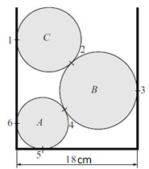
12. |  | For the truss loaded as shown in Fig.Determine thesupport reactions and the forces in members AE, BC and EC. | L5 | CO2 | [10M]
 |  | 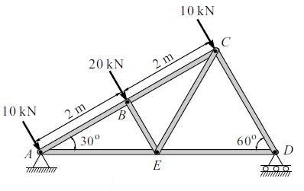
13. |  | Determine the centroid of the plane area as shown inFig. | L5 | CO3 | [10M]
 |  | 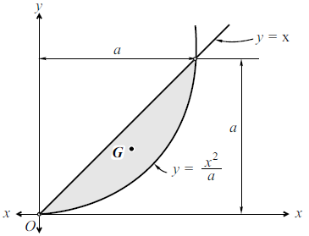
14. |  | Calculate the moment of inertia of the planearea shown in Fig.about the centroidal x-axisand centroidal y-axis. | L3 | CO4 | [10M]
 |  | 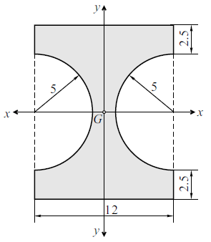
15. | a) | A burglar's car had a start with an acceleration 2 m/s . A police vigilant came in a van to the spotat a velocity of 20 m/s after 3.75 seconds and continued to chase theburglar's car with uniformvelocity. Calculate the time in which the police van will overtake the burglar's car. | L3 | CO5 | [5M]
 | b) | A particle moves in the x-y plane with velocity components v_{x} = 8t - 2 and  v_{y} = 2. If it passesthrough the point (x, y) = (14, 4) at t = 2 sec, determine the equation of the path traced bythe particle. Also find the resultant acceleration at t = 2 sec. | L5 | CO5 | [5M]
16. |  | A 20 N block is released from rest. It slides down the inclined having µ = 0.2 as shown in Fig. Determine the maximum compression of the spring and the distance moved by theblock when the energy is released from compressed spring. Springs constant k = 1000 N/m. | L5 | CO6 | [10M]
 |  | 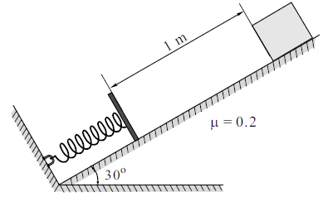
17. |  | Two blocks A and B of weight 500 N and 750 N,respectively are connected by a cord that passesover a frictionless pulley, as shown in Fig.The coefficient of friction between the block Aand the inclined plane is 0.4 and that betweenthe block B and the inclined plane is 0.3.  Determine the force P to be applied to block Bto produce the impending motion of block Bdown the plane. | L5 | CO1 | [10M]
 |  | 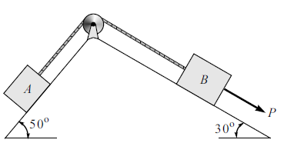
18. |  | Two particles of masses 10 kg and 20 kg are moving along a straight line towards each other atvelocities of 4 m/s and 1 m/s, respectively, as shown in Fig.16.1. If e = 0.6, determine thevelocities of the particles immediately after their collision. Also find the loss of kinetic energy. | L5 | CO4 | [10M]
 |  | 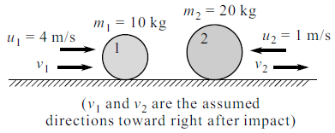
-- 00 -- 00 –

